Exp 10

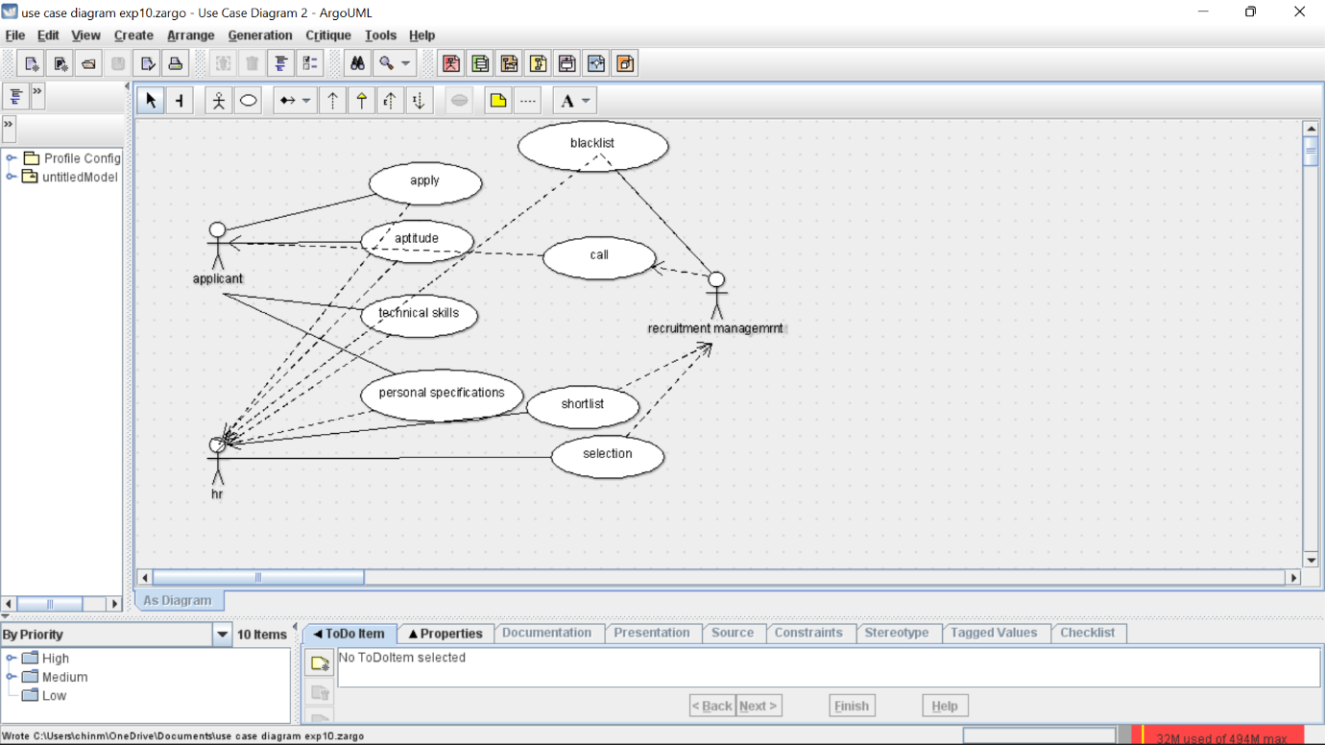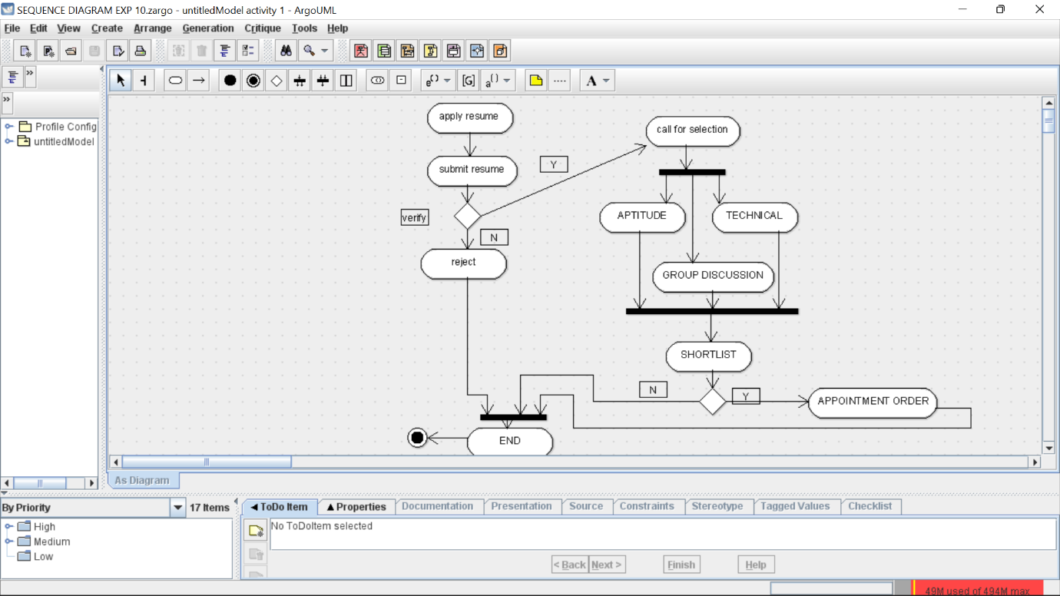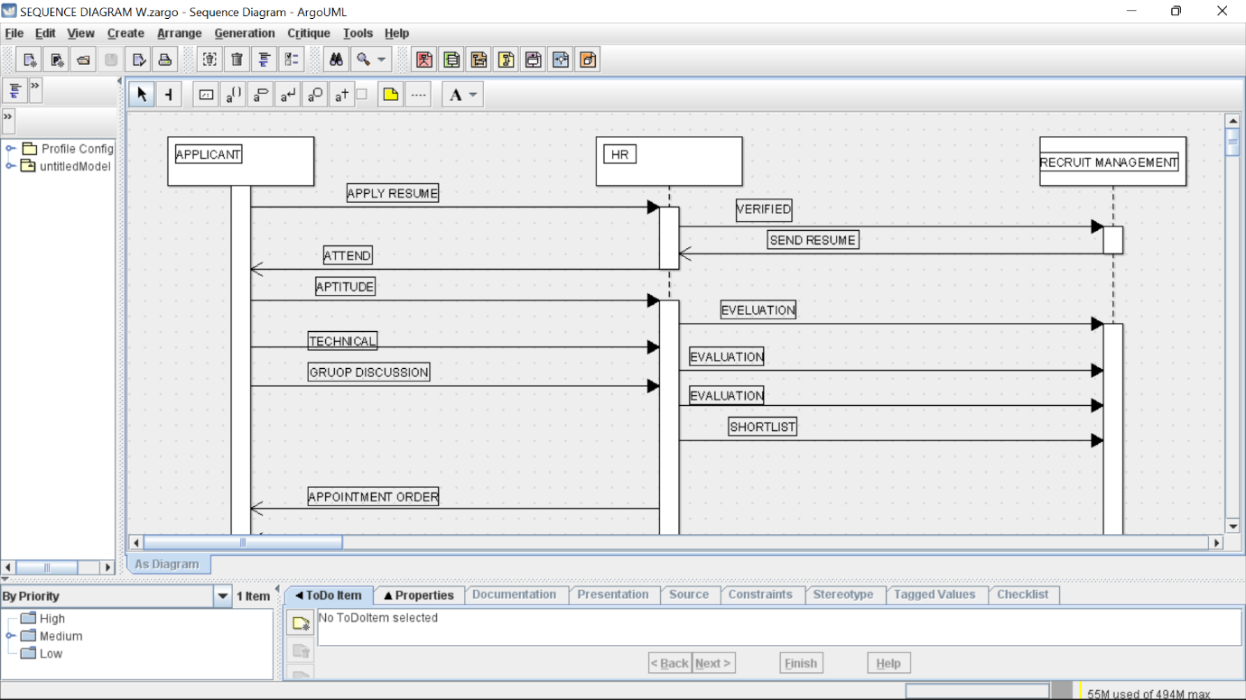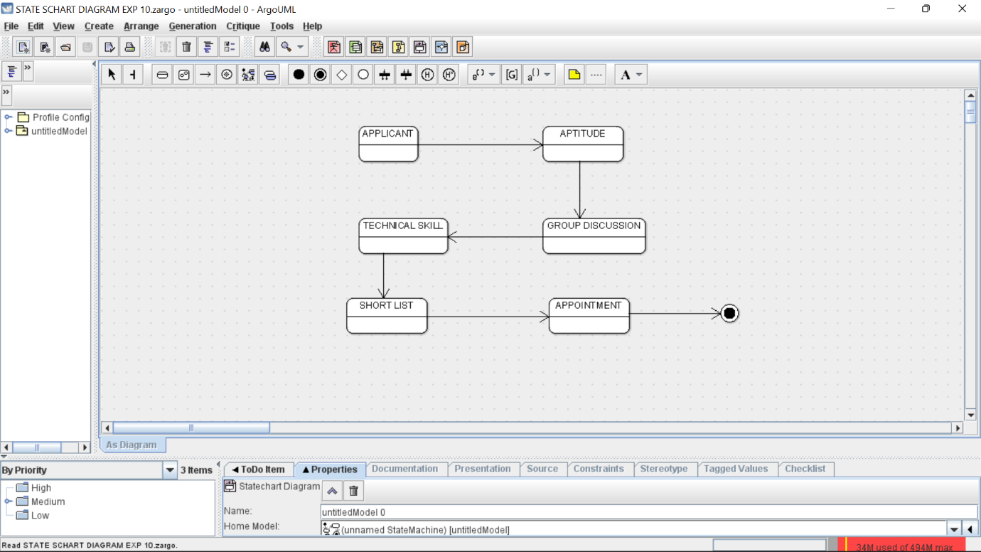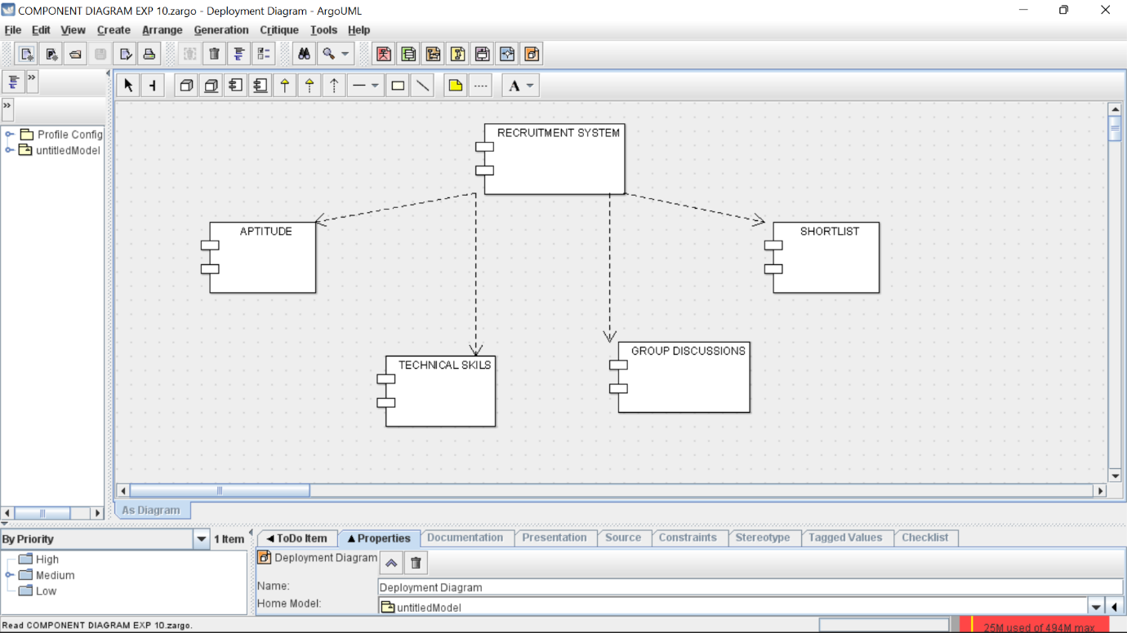

Skeleton code

import java.util.Vector;

public class applicant {

public Integer name;

private Integer specifications;

public Integer aptitude;

private Integer skills;

public Vector myrecruitment management;

public void name() {

}

public void specifications() {

}

public void sendforapproval() {

}

}

import java.util.Vector;

public class human resource {

public Integer appname;

public Integer verification;

public Integer newAttr;

public Vector myrecruitment management;

public void verifying() {

}

public void shortlist() {

}

public void newOperation() {

}

}

import java.util.Vector;

public class recruitment management {

private Integer list;

public Integer reconfirmation;

public Vector myapplicant;

public Vector myhuman resource;

public void shortlist() {

}

public void call() {

}

public void select() {

}

public void reject() {

}

}

n